**Chatbot Using Amazon Lex**

# Conversational AI Chatbot – The What, Why and Everything Else

“A chatbot is a computer-based program that simulates human conversations. Commonly known as digital assistants, chatbots allow humans to interact with them and make the experience a realistic one.”

# 🡪amazon lex supports in north virginia

**AMAZON LEX:** Amazon Lex is a fully managed artificial intelligence (AI) service with advanced natural language models to design, build, test, and deploy voice and text conversational interfaces in applications**.**

# 

**Amazon Lex**

**What is intent?**

Within a chatbot, intent refers to the goal the customer has in mind when typing in a question or comment. While entity refers to the modifier the customer uses to describe their issue, intent is what they really mean.

Can I order pizza

I want to order a pizza

**What is slot?**

A slot is an information that Amazon lex needs to fulfill an intent. Each slot has a slot types. You can create your custom slot types or use built in slot types

For example, the order pizza intent requires slots such as pizza size and pizza type.

**What is slot Type?**

Each Slot has a type. You can create your slot type or use buit-in slot types.

For example you might create and use the following slot types for the order pizza intent.

Size small, medium and large

Crust thick or thin

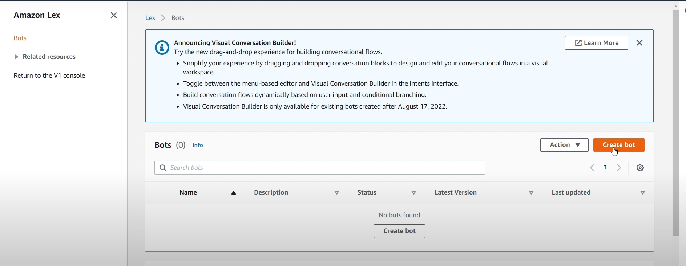

Create a bot

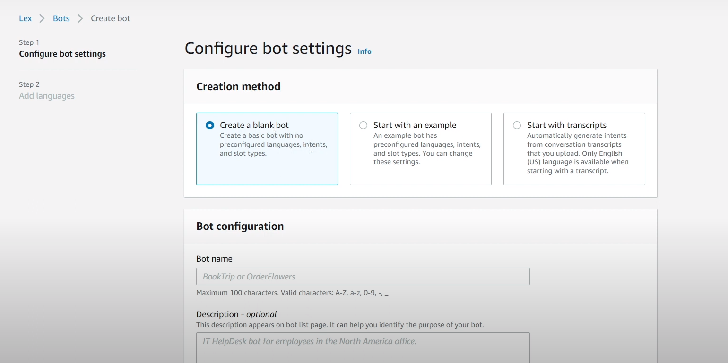

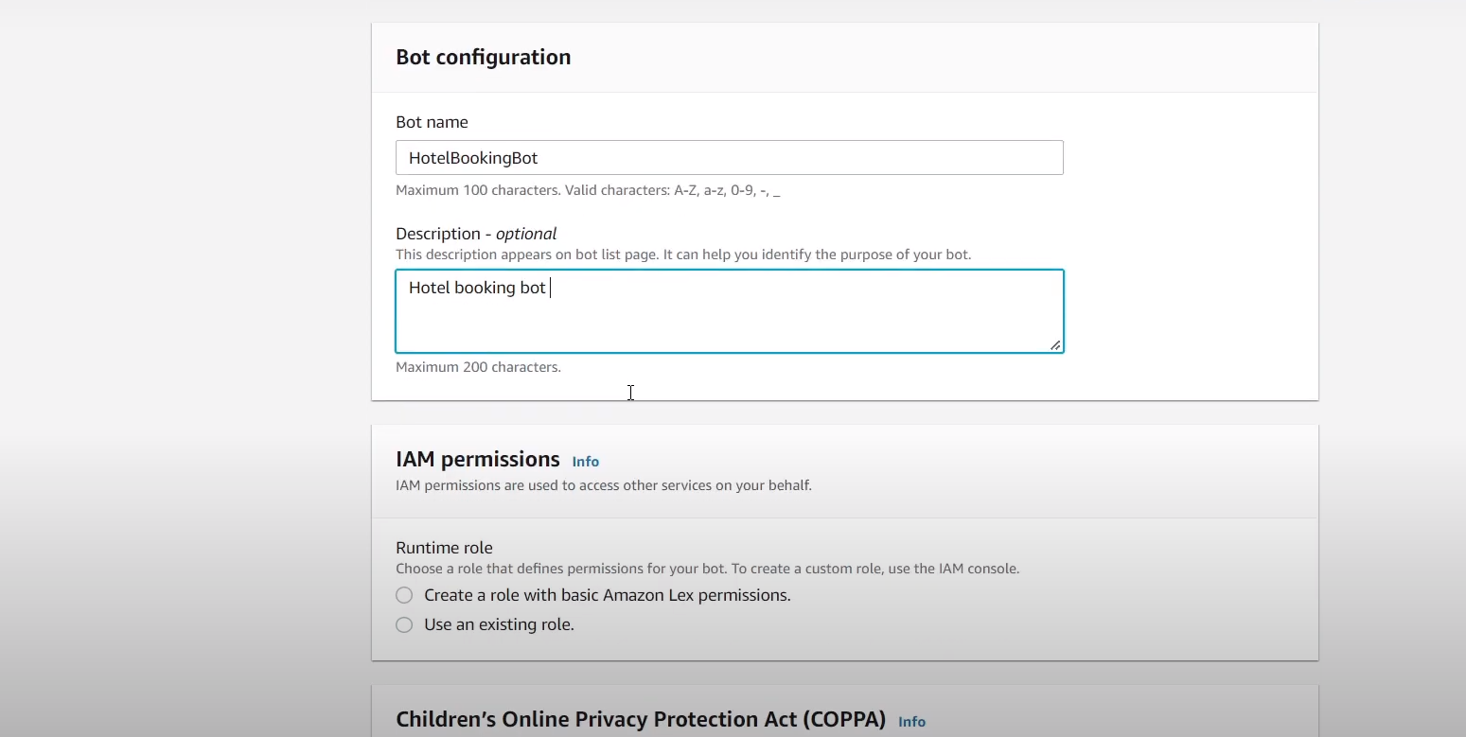

Create a role with basic amazon lex permissions.

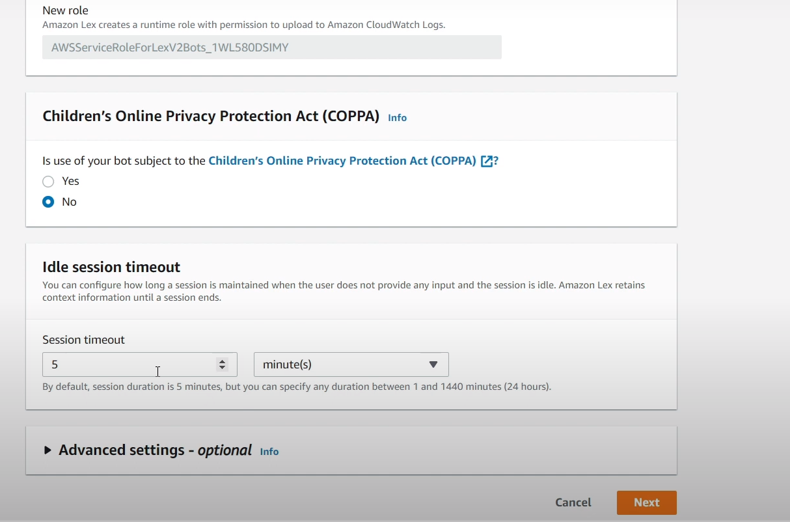

Configuring of bot settings

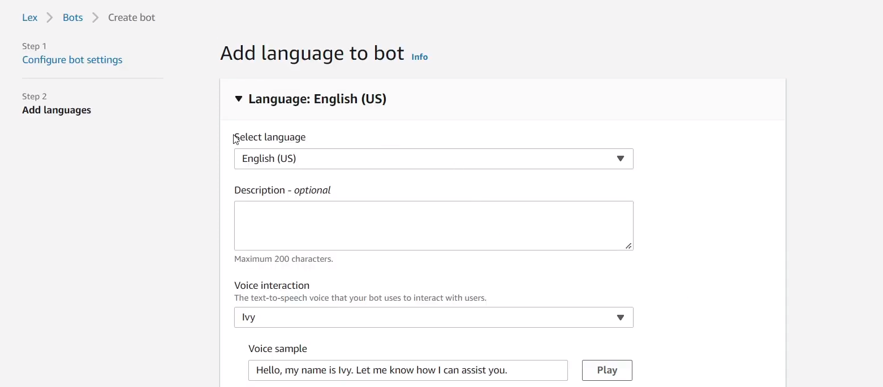

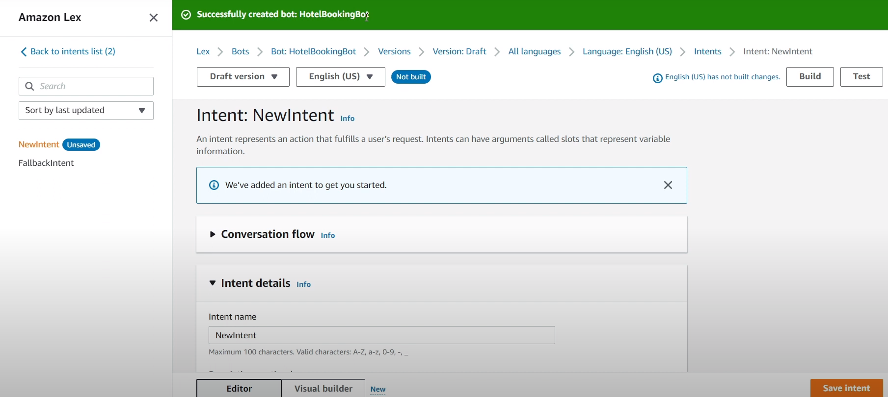

Create a new intent

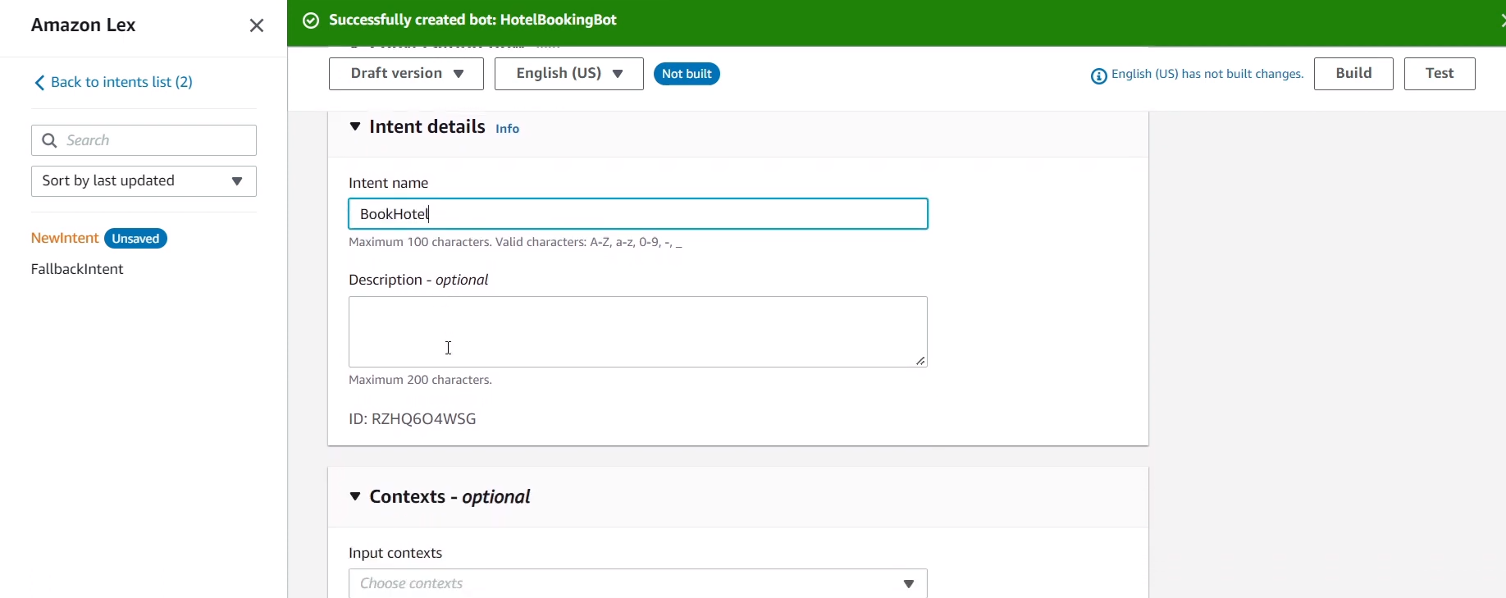

## **Intent:**

## Book hotel

## I want to make a hotel reservation

## Book 3 night stay In Mumbai

## Book A {night} stay in {location}

## 

## **Slots:**

## **Location**:

## **Prompts** : What city will you be staying in?

## 

## **Checkin date:**

## Prompts:What day do you want to check in?

## 

## **Nights:**

## Prompts: How many nights will you be staying?

## 

## **Roomtype: (slot type)**

## Prompts: What type of room would you like , Queen, King, Deluxe and Super Deluxe?

## 

## **Confirmation Prompt:**

## Okay, I have you down for a {Nights} night stay in{Location} starting {CheckIndate}.Shall I book the reservation?

## 

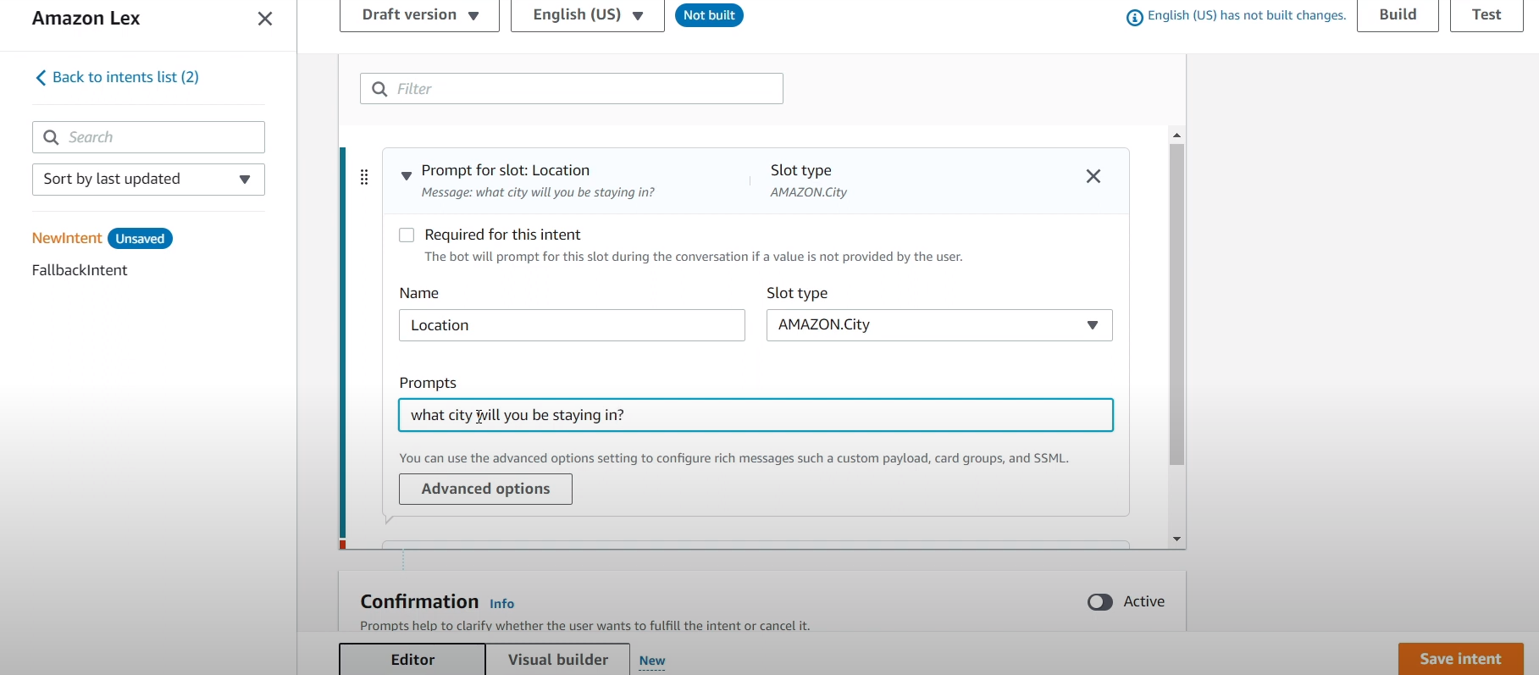

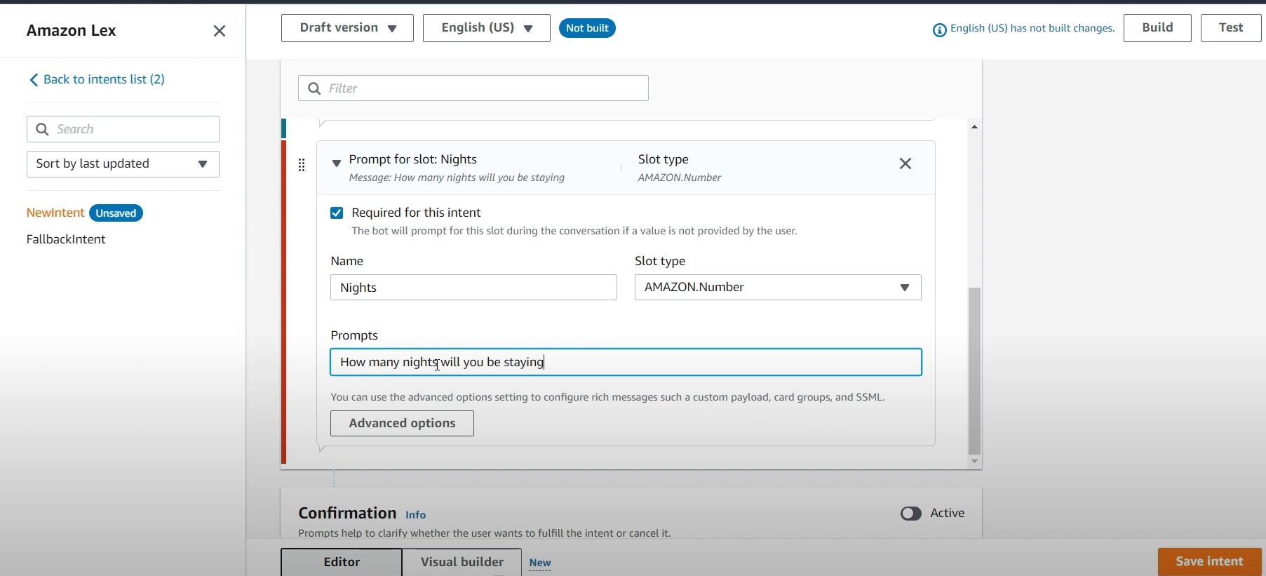

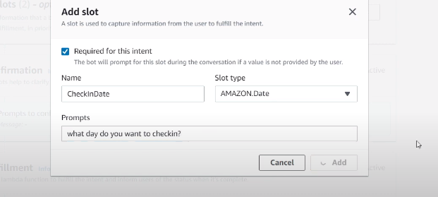

Back to intents list->slot types->create a blank slot type

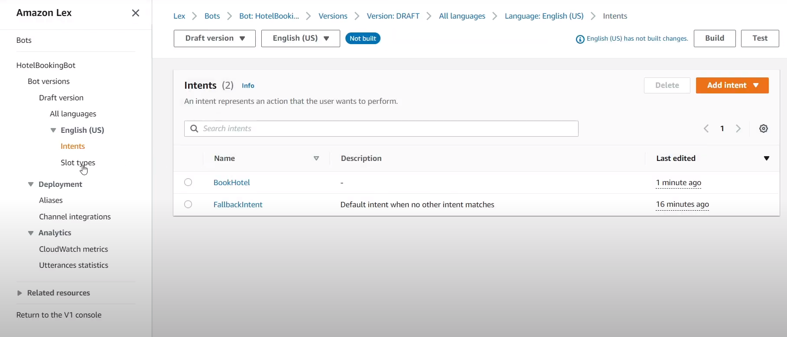

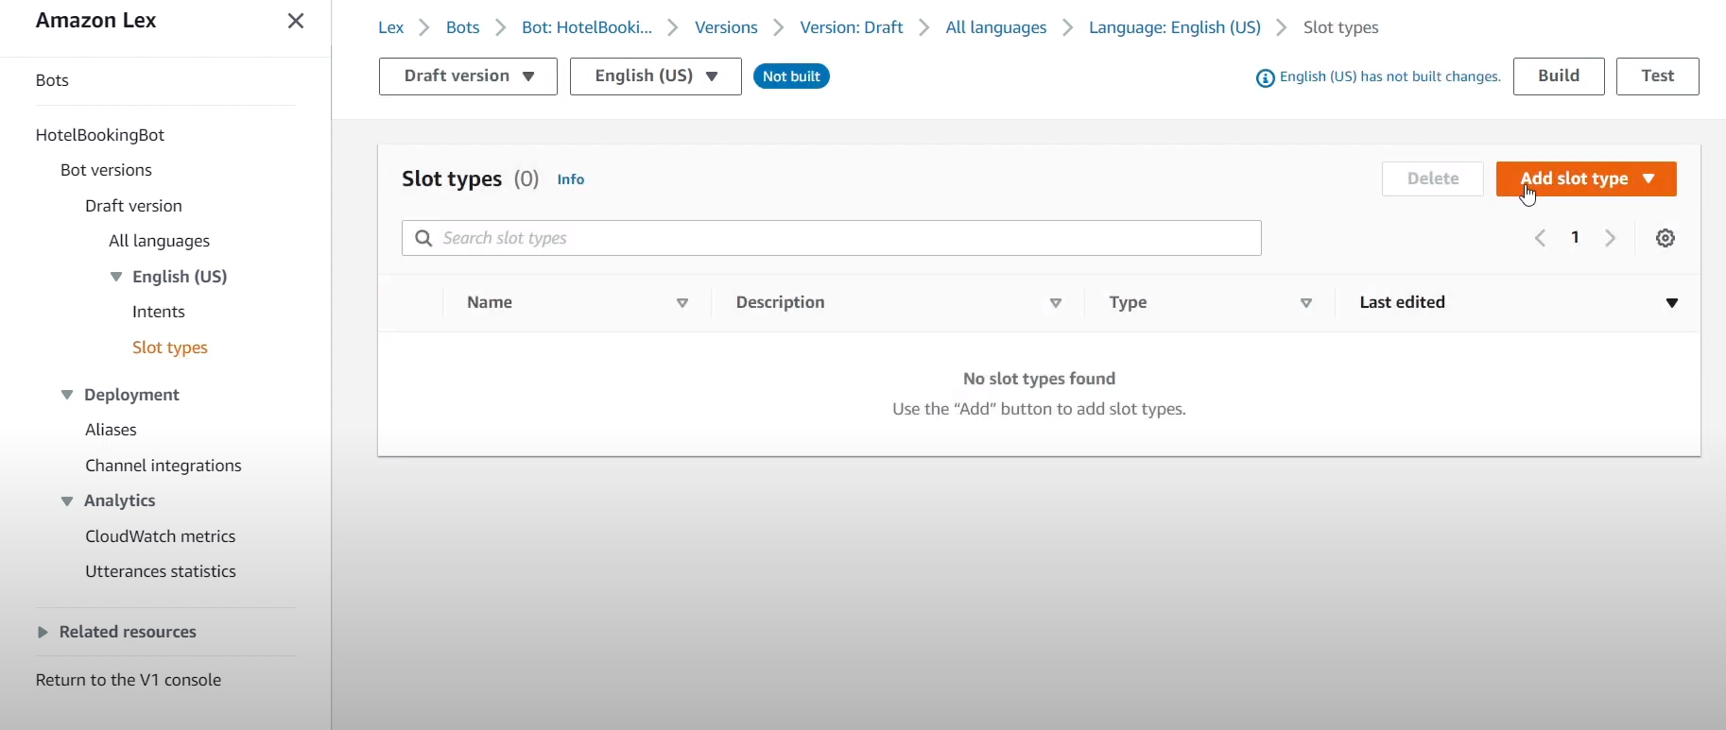

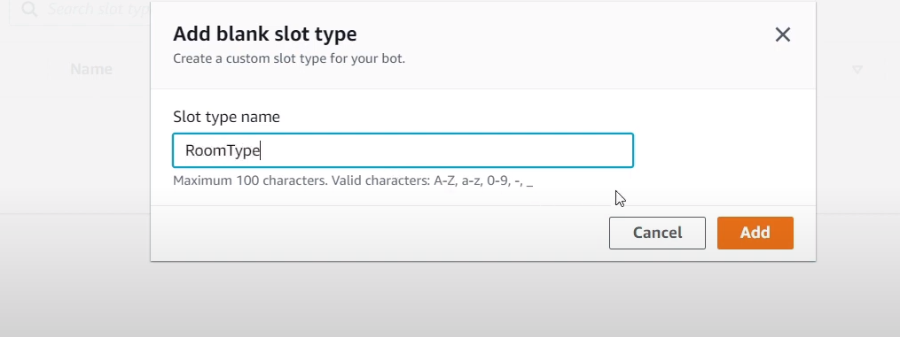

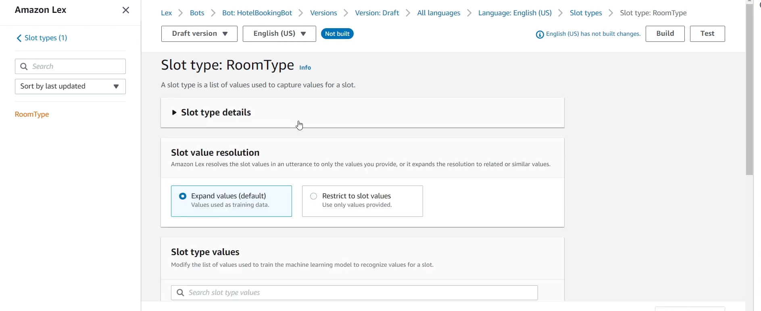

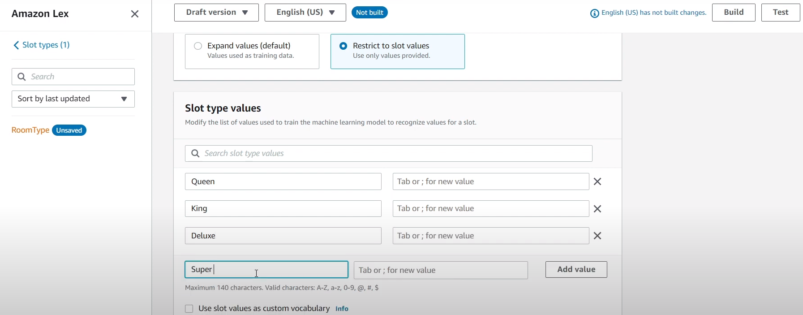

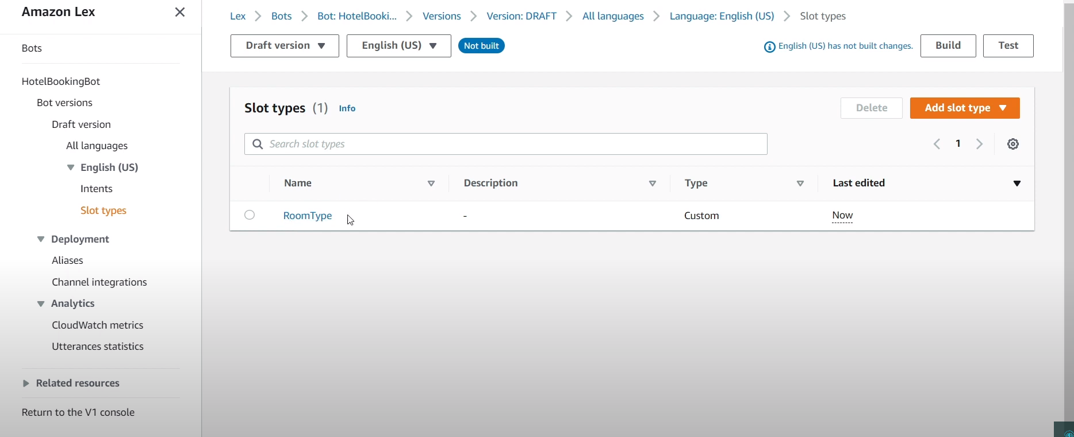

Again open intent->book hotel->add slots->add slot type->room type

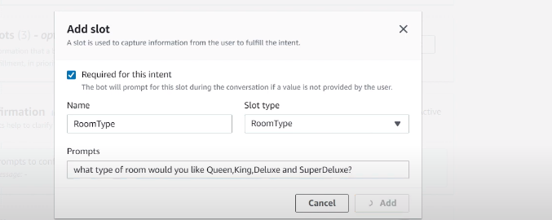

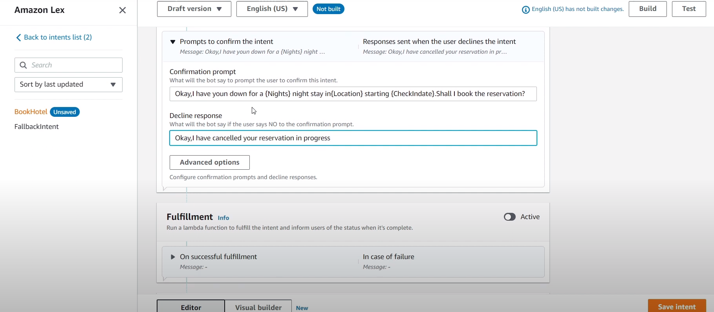

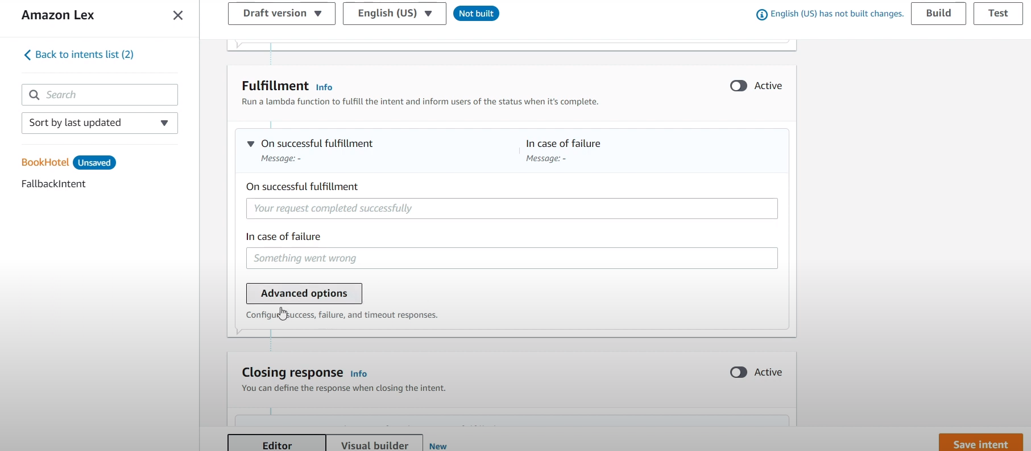

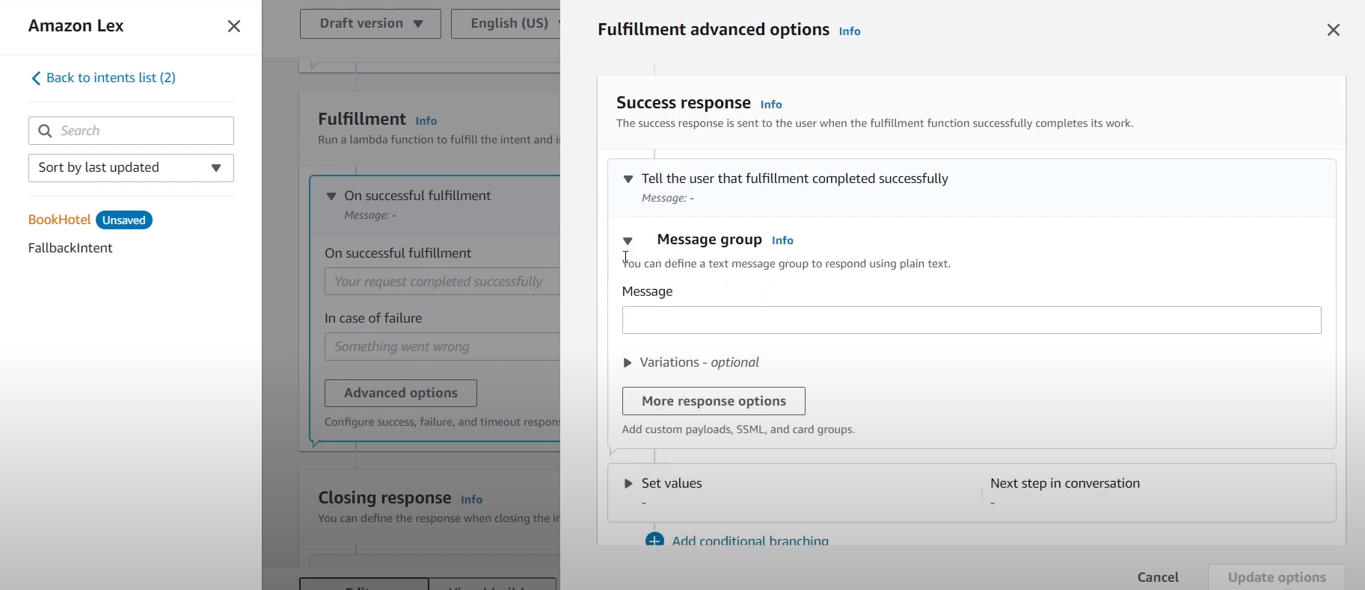

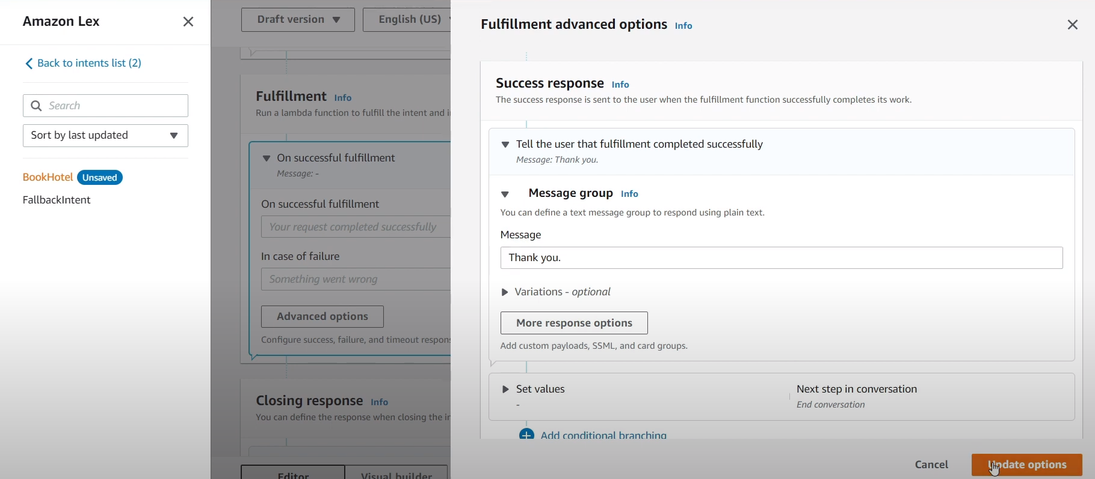

After saving the intent build the intent

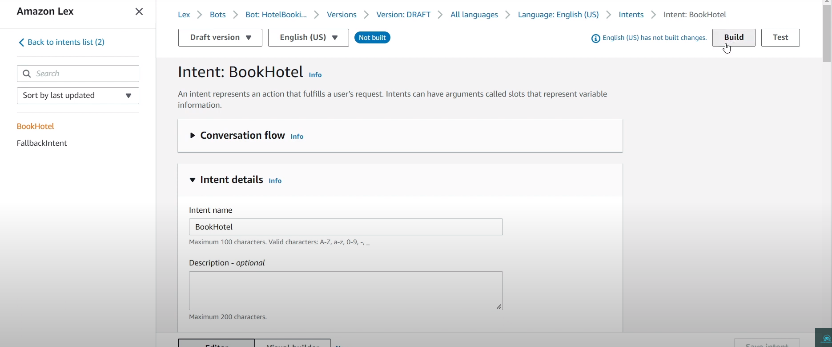

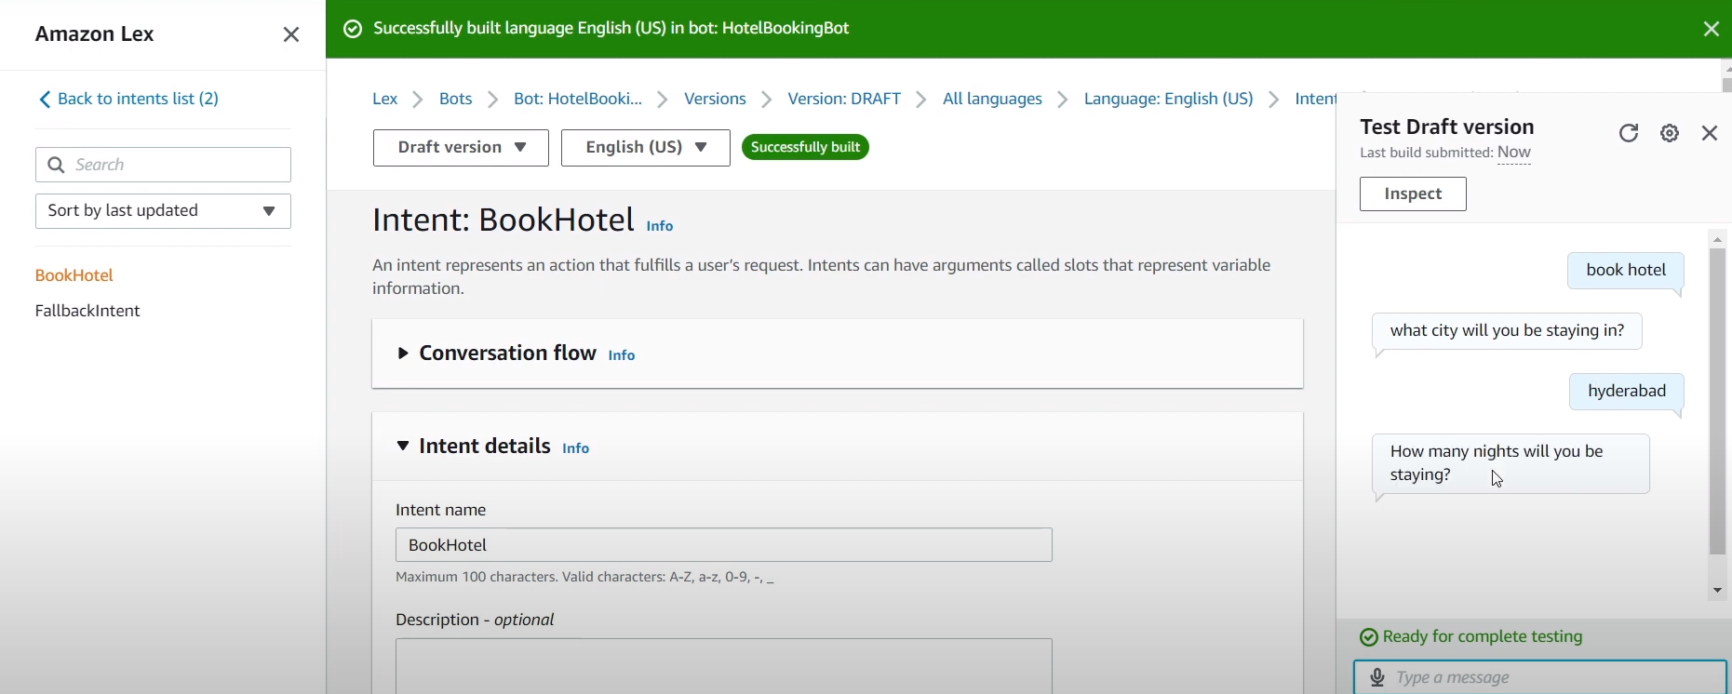

Open aws lambda and create a function.

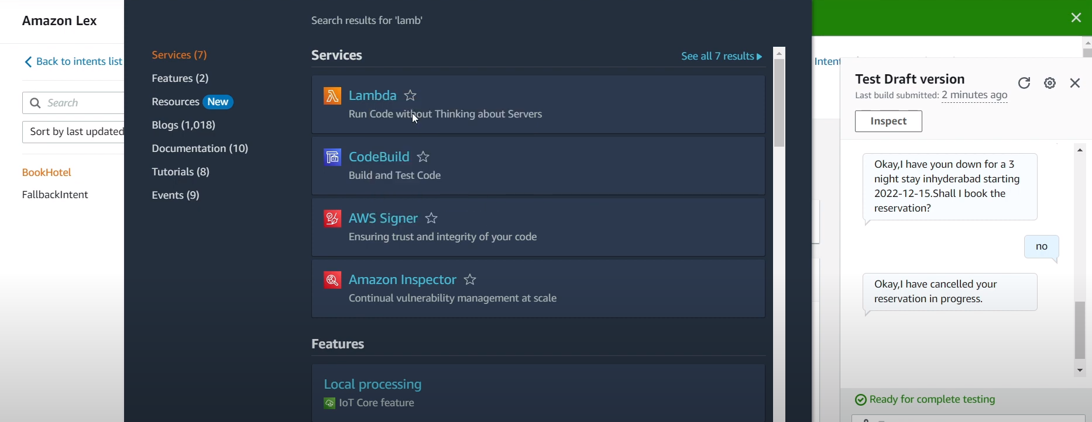

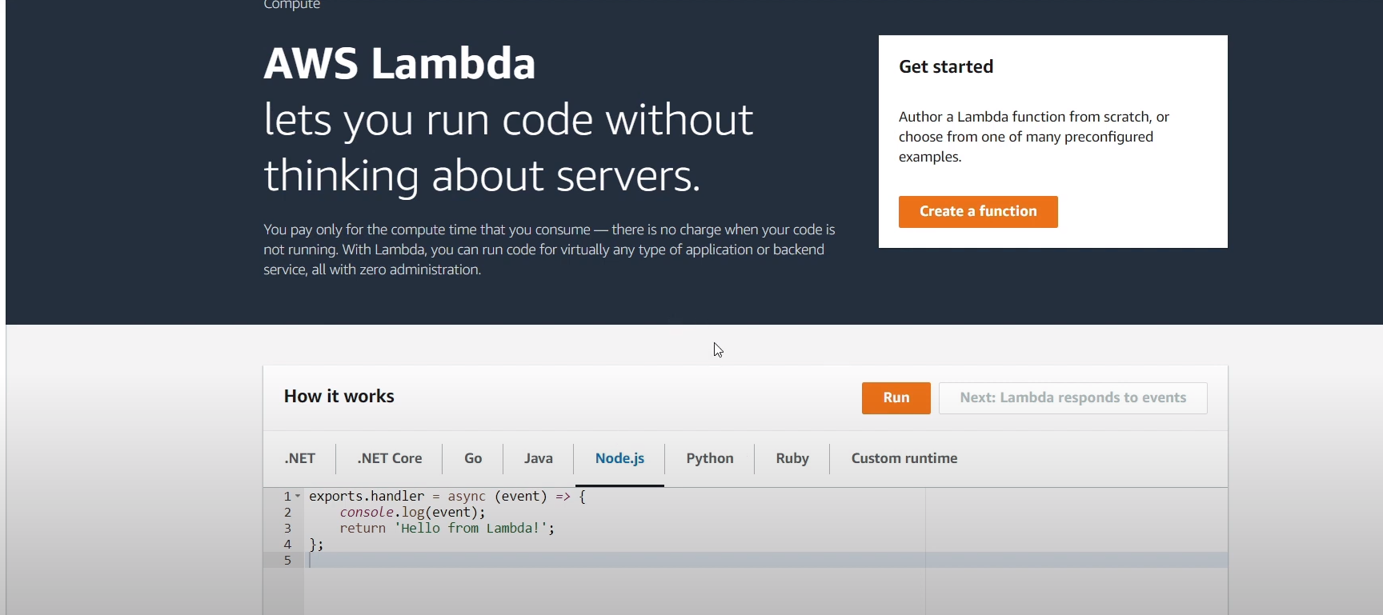

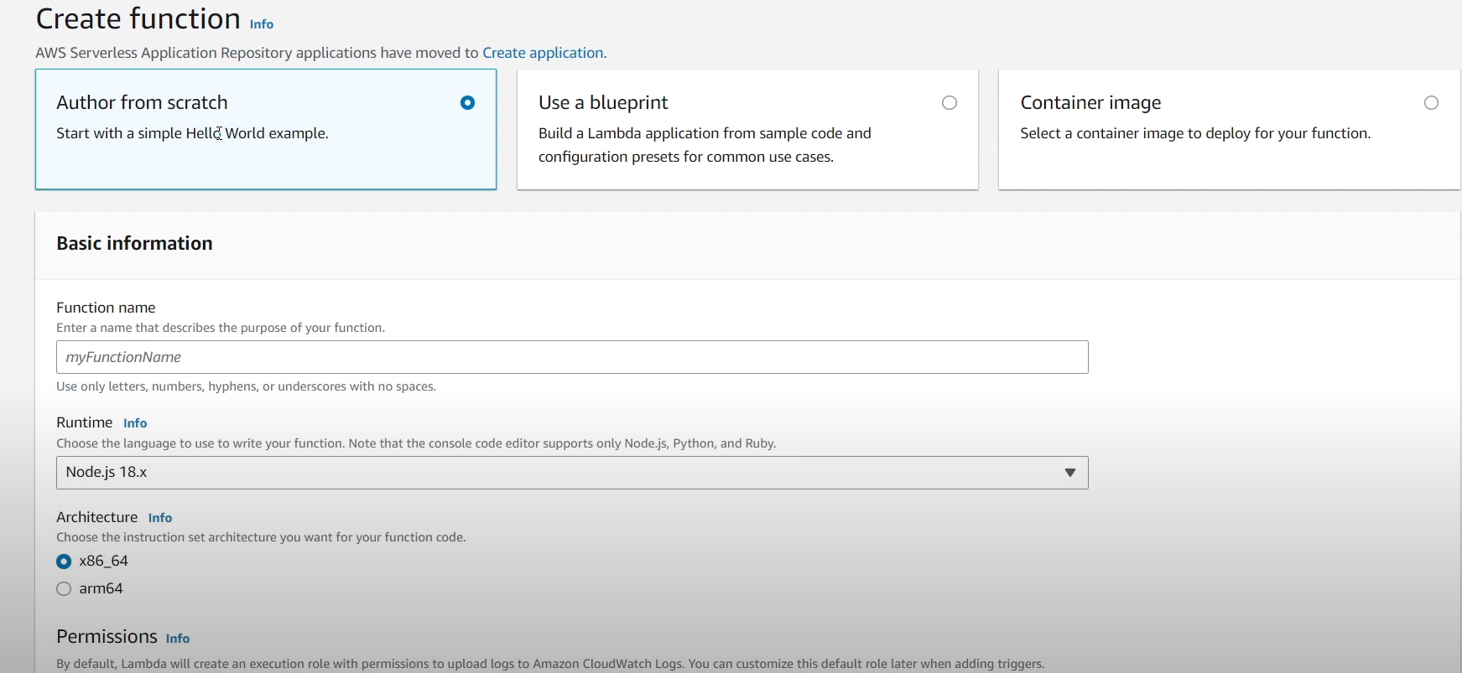

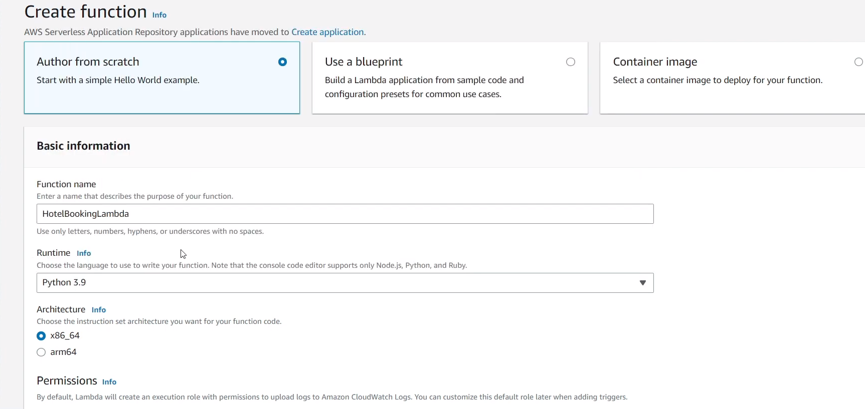

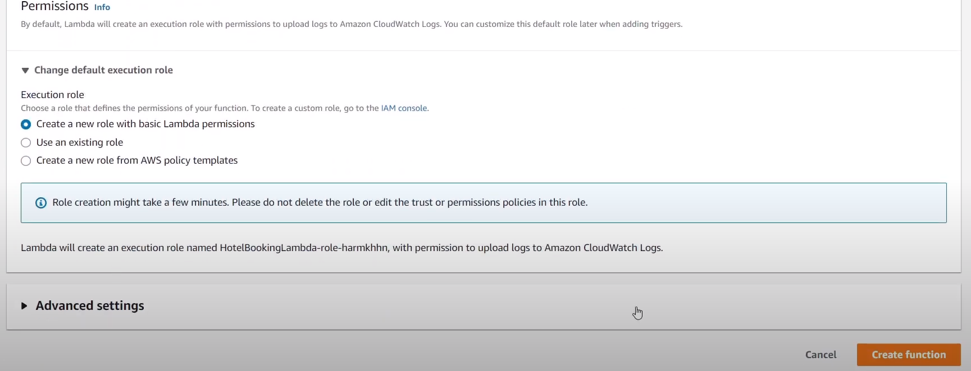

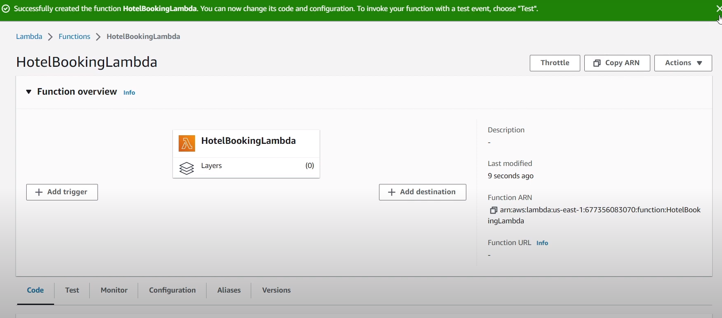

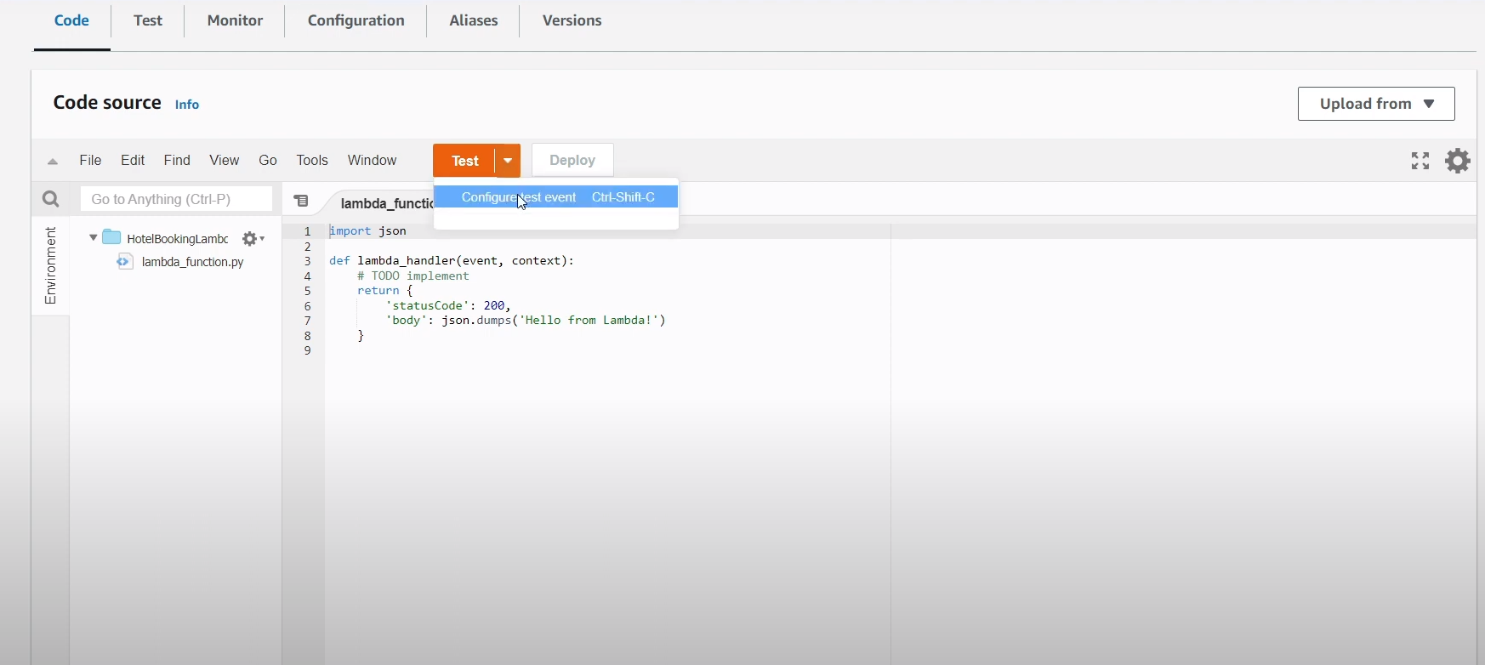

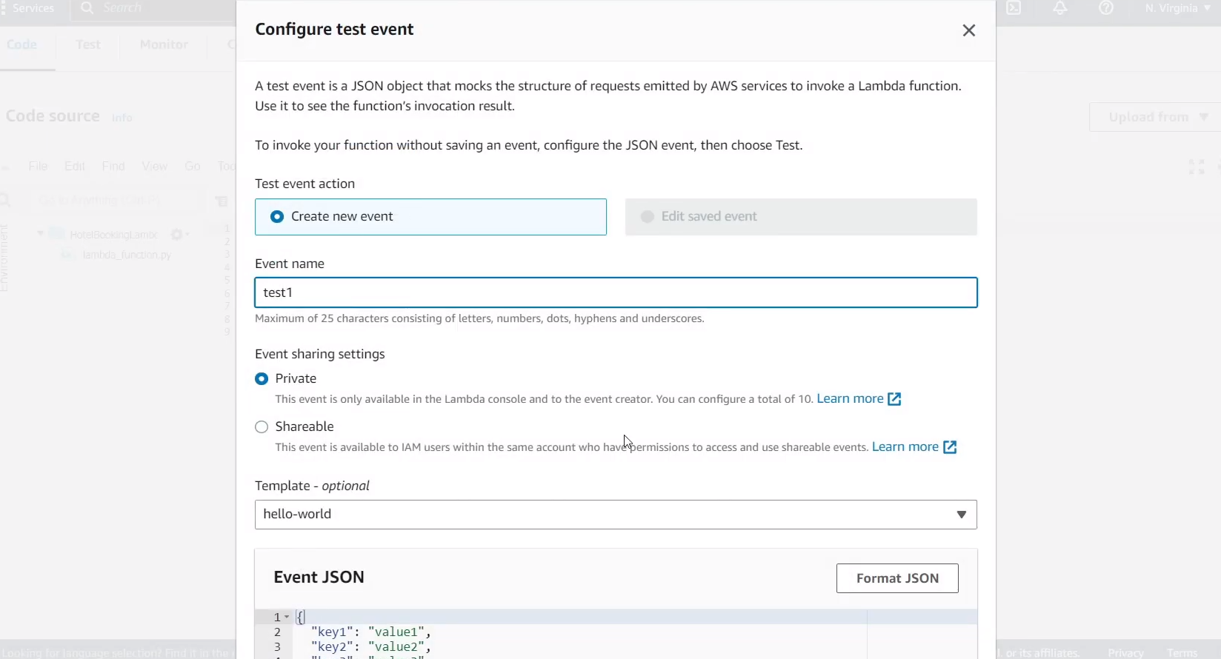

**Save it and then test it**

**#aws lambda code for**

**#How to Make a Chatbot Using Amazon Lex and AWS Lambda (Python) | Conversational AI Part 2**

**import json**

**import datetime**

**import time**

**def validate(slots):**

**valid_cities = ['mumbai','delhi','banglore','hyderabad']**

**if not slots['Location']:**

**print("Inside Empty Location")**

**return {**

**'isValid': False,**

**'violatedSlot': 'Location'**

**}**

**if slots['Location']['value']['originalValue'].lower() not in valid_cities:**

**print("Not Valide location")**

**return {**

**'isValid': False,**

**'violatedSlot': 'Location',**

**'message': 'We currently support only {} as a valid destination.?'.format(", ".join(valid_cities))**

**}**

**if not slots['CheckInDate']:**

**return {**

**'isValid': False,**

**'violatedSlot': 'CheckInDate',**

**}**

**if not slots['Nights']:**

**return {**

**'isValid': False,**

**'violatedSlot': 'Nights'**

**}**

**if not slots['RoomType']:**

**return {**

**'isValid': False,**

**'violatedSlot': 'RoomType'**

**}**

**return {'isValid': True}**

**def lambda_handler(event, context):**

**# print(event)**

**slots = event['sessionState']['intent']['slots']**

**intent = event['sessionState']['intent']['name']**

**print(event['invocationSource'])**

**print(slots)**

**print(intent)**

**validation_result = validate(event['sessionState']['intent']['slots'])**

**if event['invocationSource'] == 'DialogCodeHook':**

**if not validation_result['isValid']:**

**if 'message' in validation_result:**

**response = {**

**"sessionState": {**

**"dialogAction": {**

**'slotToElicit':validation_result['violatedSlot'],**

**"type": "ElicitSlot"**

**},**

**"intent": {**

**'name':intent,**

**'slots': slots**

**}**

**},**

**"messages": [**

**{**

**"contentType": "PlainText",**

**"content": validation_result['message']**

**}**

**]**

**}**

**else:**

**response = {**

**"sessionState": {**

**"dialogAction": {**

**'slotToElicit':validation_result['violatedSlot'],**

**"type": "ElicitSlot"**

**},**

**"intent": {**

**'name':intent,**

**'slots': slots**

**}**

**}**

**}**

**return response**

**else:**

**response = {**

**"sessionState": {**

**"dialogAction": {**

**"type": "Delegate"**

**},**

**"intent": {**

**'name':intent,**

**'slots': slots**

**}**

**}**

**}**

**return response**

**if event['invocationSource'] == 'FulfillmentCodeHook':**

**# Add order in Database**

**response = {**

**"sessionState": {**

**"dialogAction": {**

**"type": "Close"**

**},**

**"intent": {**

**'name':intent,**

**'slots': slots,**

**'state':'Fulfilled'**

**}**

**},**

**"messages": [**

**{**

**"contentType": "PlainText",**

**"content": "Thanks, I have placed your reservation"**

**}**

**]**

**}**

**return response**

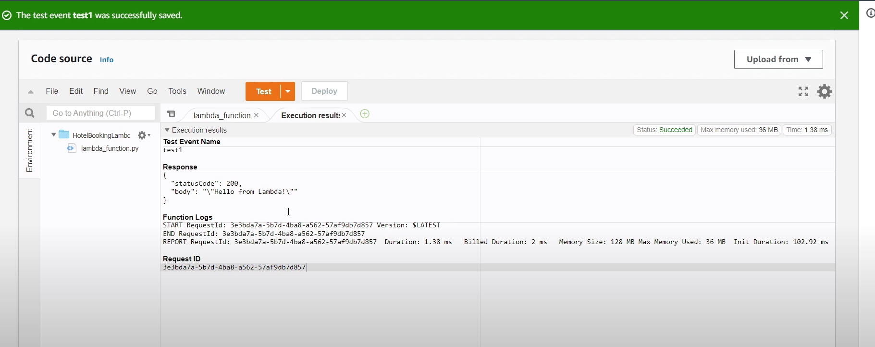

To connect amazon lex to aws lambda

Click aliases

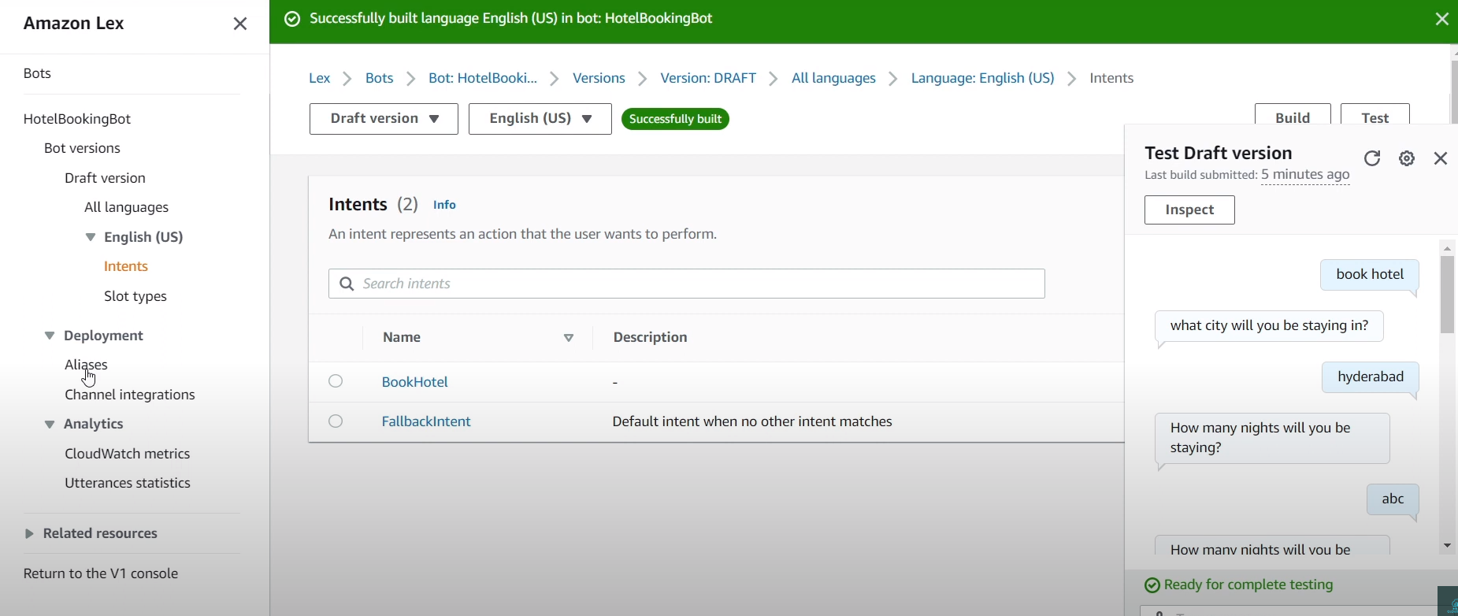

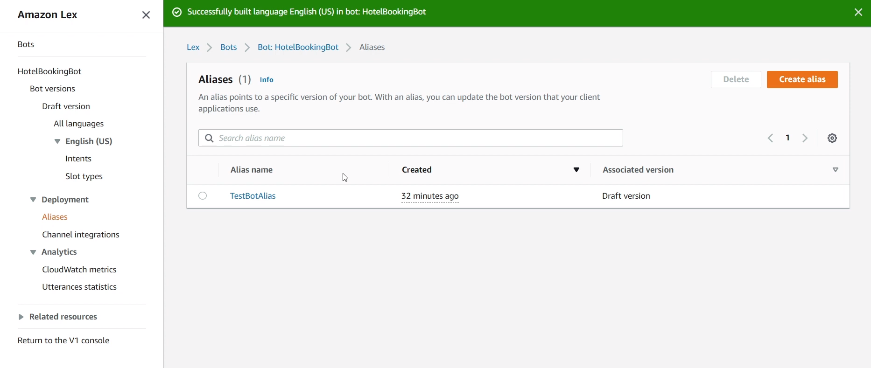

Default bot

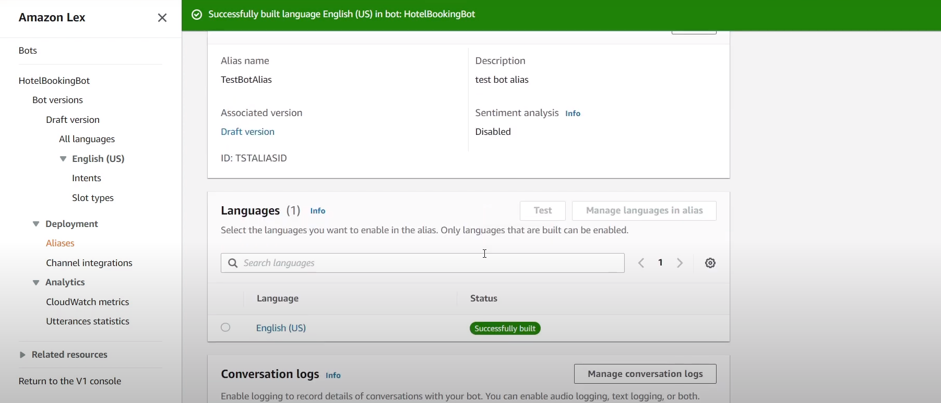

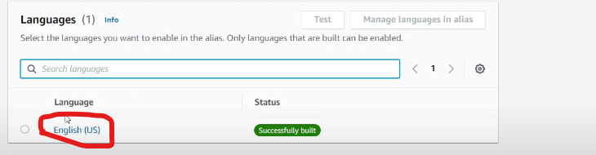

Click on that

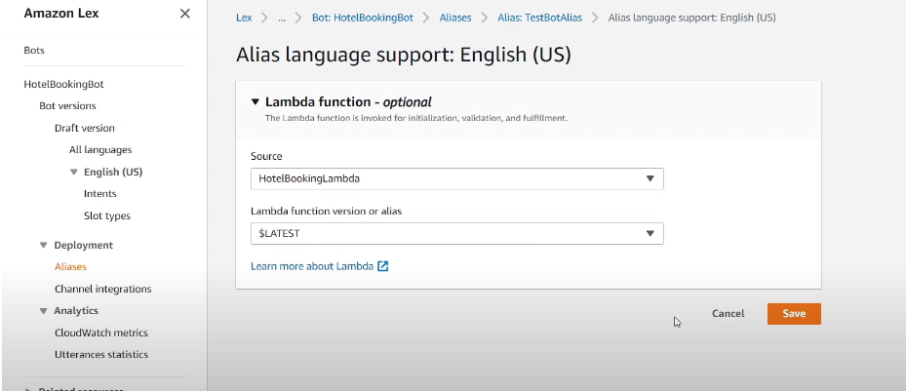

Save it

Then go to intents

Click settings then we can see lambda function is connected to lex

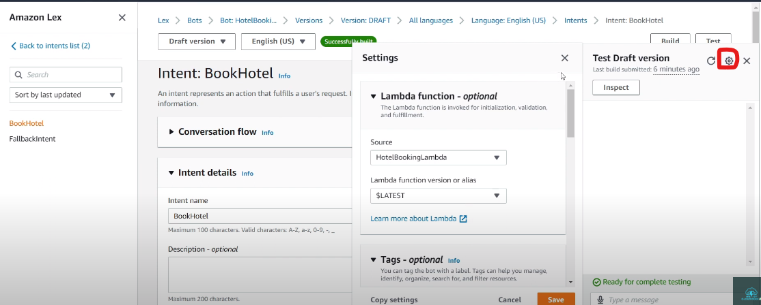

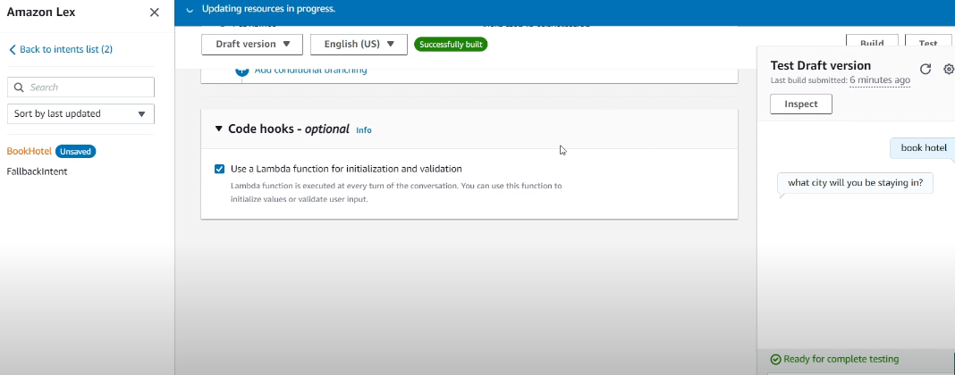

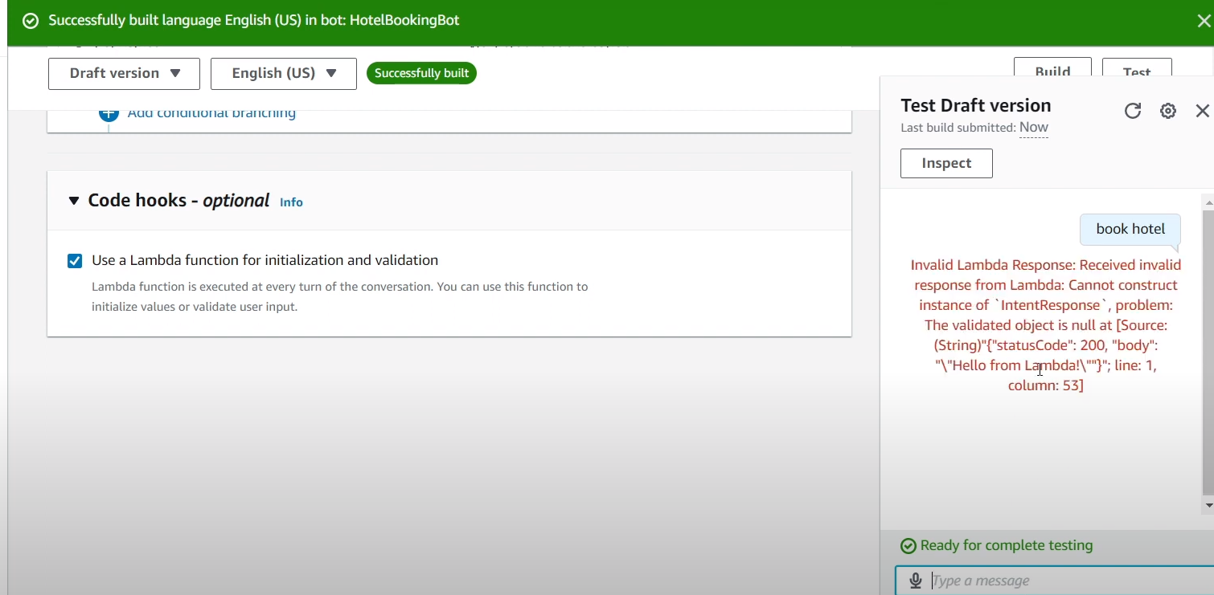

Here you can see error in bot

Change the code

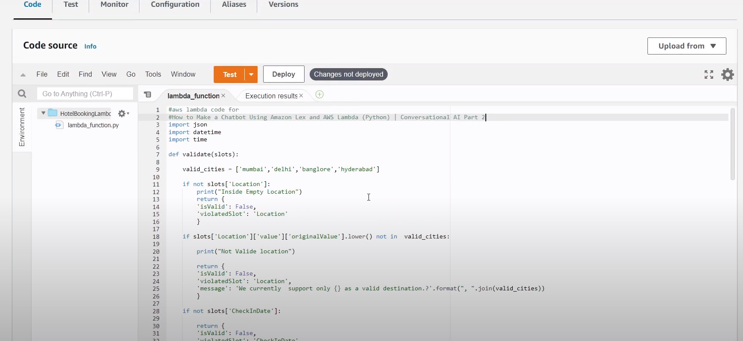

After pasting the code click on **deploy**

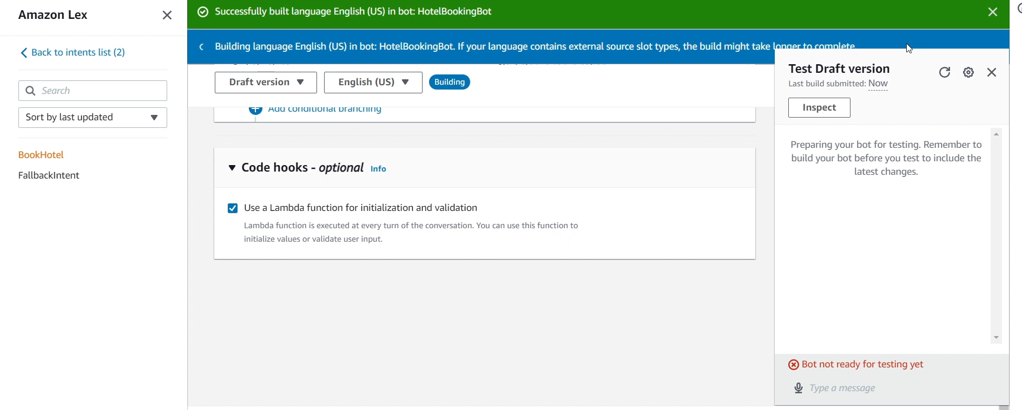

**Build it every time**

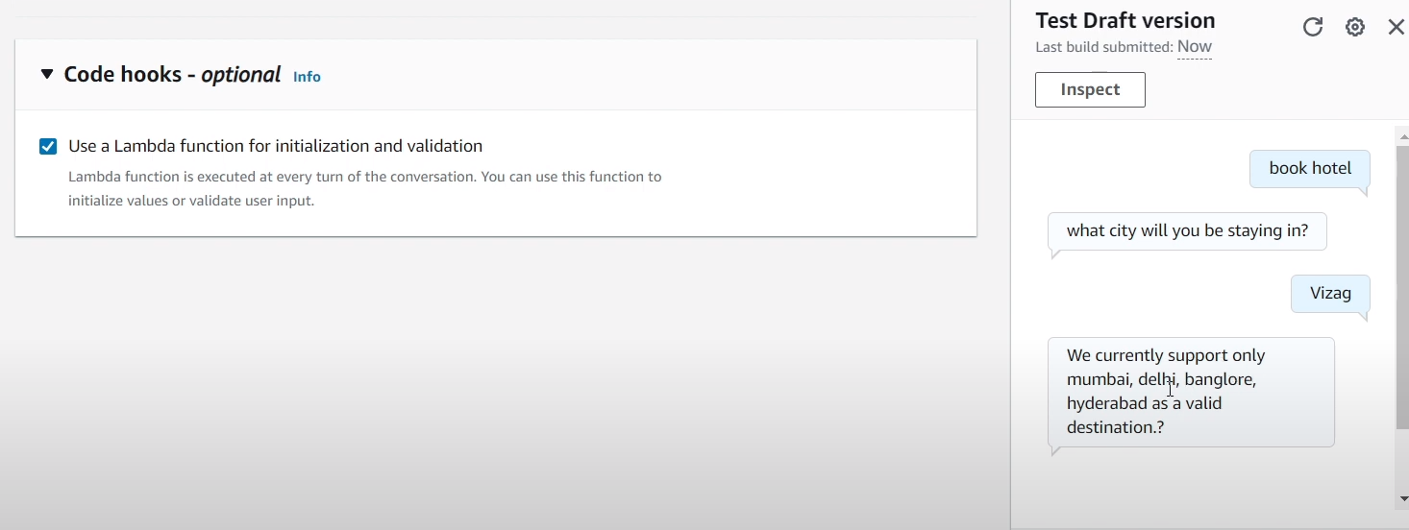

**Accorfing to code chatbot is integrated by the aws lambda code**

**If we want to integrate it whatsapp use twillo**